



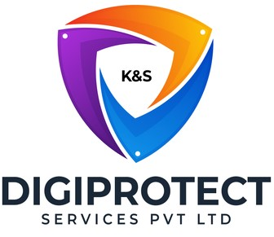

INITIAL
ASSESSMENT
REPORT

DATE: 11th June 2024
Sales

VERSION: 1.1

Document History
Document version | Remarks | Submitted  By | Submission  Date | Approved BY | Approval  Date
1.0 | First Draft | k&S Digiprotect | 3rd June 2024
1.1 | Final Draft | k&S Digiprotect | 11th June 2024

Table of Contents
Introduction 4
Objectives 4
General Information 5
SPOC Information 5
Department Hierarchy* 6
Observations 7
Data Flow Diagram (DFD) 10
Data Mapping and Inventory 11
Recommendations 12
Action Plan (ISFC to share the following) 12
Conclusion 12
Appendices 13
Appendix A 13

Introduction
The Sales Department of India Shelter Finance Corporation Limited (ISFC) is instrumental in driving the company's growth by acquiring new customers and managing loan disbursements. The team operates across seven zones and handles a significant volume of loan applications, ensuring thorough documentation.
This report encapsulates critical insights for As-Is study, derived from the initial interview conducted with the Sales Department of India Shelter Finance Corporation Limited (ISFC) for the implementation of ISO/IEC 27001:2022 and compliance with the Digital Personal Data Protection Act (DPDPA).
The overarching objectives of this interview were dual fold: first, to gain an understanding of the departmental structure, and second, to delve into the core operational processes of the Sales Department. Additionally, the interview aimed to assess the existing information security practices, focusing on evaluating adherence to DPDPA requirements and the readiness for ISO/IEC 27001:2022 implementation.
By delving into the details of the department's organizational setup, operational workflows, and data handling procedures, this report aims to identify both the strengths and areas of improvement in information security management and DPDPA compliance within the department.

Objectives
- Understand the departmental hierarchy and reporting structure
- Learn the existing processes of ISFC’s Sales Department
- Mapping of existing processes with documented processes
- Offer recommendations to optimize the existing processes

General Information
Organization Name | India Shelter Finance Corporation Limited
Department Name | Sales Department
Date of the Assessment | 7th May 2024
Location | Basement, India Shelter HQ, Gurugram
Meeting Duration | 40 minutes
Attendees (ISFC) | Puneet Kumar Sachdeva, Dheeraj Yadav, Sunil Kumar Sharma
Attendees (Digiprotect) | Lalit Mohan Joshi, Sushil Menon, Adhita Razdan

SPOC Information
Project SPOC: Dheeraj Yadav
Contact Information:
Email ID: dheeraj.yadav@indiashelter.in

Project Coordinator: Sunil Kumar Sharma
Contact Information:
Email ID: sunil.sharma2@indiashelter.in

Department SPOC: Puneet Kumar Sachdeva
Contact Information:
Email ID: puneet.sachdeva1@indiashelter.in

Department Hierarchy*

* As informed during the meeting

Observations
S. No | Key Activities | Observations and Asks | Remarks
 | Loan Sourcing and File Submission  - Loan sourcing is conducted by Loan Officers through various methods such as direct business sourcing, personal references, and cold calling.  - Comprehensive documentation is collected for each loan application to ensure eligibility and credibility. This includes basic personal information, income documents, bank statements, KYC documents, and relevant property papers.  - The department currently uses two applications, iSales and iTrust, which are connected to Salesforce for logging loan applications. Both systems perform the same functions and are operating in parallel.  - The department plans to fully transition to the iTrust App soon, although no specific timeline has been defined yet.  - Access to modify loan application details is restricted to the EBS and Credit manager, while upload access is designated for the sales team on ground.  - Connectors act as intermediaries, providing references for potential customers without direct involvement in the loan application process. | NA
 | Document Verification and Approval  - The submitted documents are reviewed for accuracy and completeness. This verification step is crucial to identify any missing or incorrect information early in the process, preventing delays and ensuring smooth processing.  - Business Managers and Loan Officers engage with customers to clarify any doubts and gather additional information such as missing documentation, explanations for provided documents, and any other details required for the loan approval process.  - Customers are required to visit the branch for in-person document signing. This ensures that all legal requirements are met and provides an opportunity for any final clarifications.  - They are then forwarded to the EBS for detailed scrutiny and approval. | NA
 | Loan Applications Management  - Customers are required to self-attest their documents before these documents are digitally uploaded.  - Physical files are maintained for each loan application.  - Documents against queries raised by Internal teams during verification process are collected by Loan Officers.  - Visibility of all customer data related to loan approvals is maintained throughout the process, allowing relevant personnel to access necessary information for efficient processing.  - The sales team handles the initial file login checklist, ensuring all application documents are correctly logged.  - The operations team manages the loan closure checklist, verifying that all closing documents are in order. | - All sales-generated leads are kept indefinitely, even if initially uninterested.  - There is no expiration on lead generation.
 | Loan Disbursement and Closure  - Customers are flagged as early defaults if EMI payments are not received within the first 18 months.  - Early identification of defaults allows the department to take proactive measures to manage and mitigate credit risk effectively.  - The department processes approximately 3000 fresh disbursements per month | NA

Data Flow Diagram (DFD)
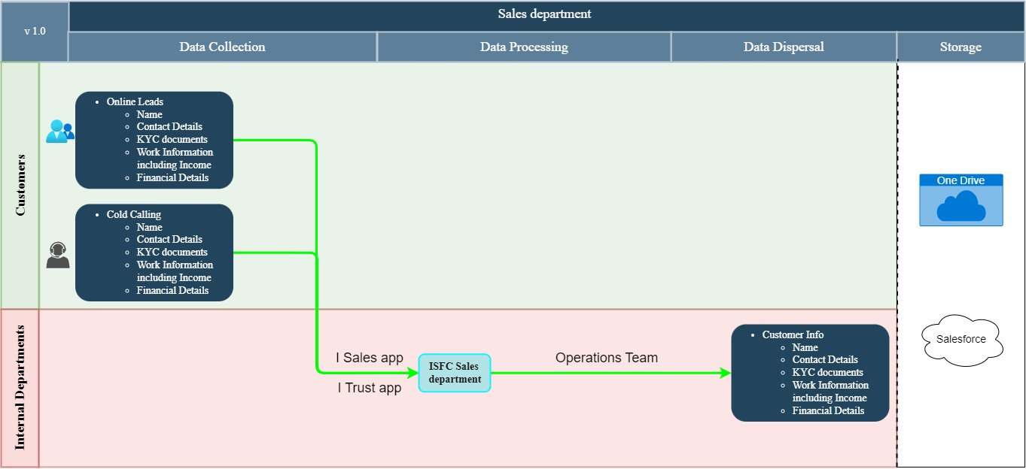

Data Mapping and Inventory
S. No | Data Category | Description | Purpose | Data Owner | Storage Location | Data Classification* | Retention Period | Legal Basis
1. | Loan Sourcing Data | Potential Customer References | Used for lead generation | Sales Department | iSales/iTrust/Salesforce | PII/Sensitive data | Not Defined | Consent
2. | Customer Info | Personal information of customers recorded after lead generation  (KYC documents, Bank account details, Property papers and Income documents) | Used for Customer identification and loan processing | Sales Department | iSales/iTrust/Salesforce | PII/Sensitive data | Not Defined | Consent
3. | Document Verification Records | Verified and self-attested documents | Ensure accuracy and completeness of loan application | Sales Department | iSales/iTrust/Salesforce/ Physical documents | PII/Sensitive data | Not Defined | Legal Requirement
4. | Customer Interaction Records | Details of interaction with potential customers | Improve sales pitch/ cold calling efforts | Sales Department | Salesforce/ One Drive | PII/Sensitive data | Not Defined | Consent

Recommendations
- Data Minimization and Purpose Limitation
- Ensure that only necessary data is collected for loan processing and lead generation purposes.

- Consent Mechanism
- Implement clear and explicit consent mechanisms for collecting customer information and potential customer references.
- Ensure consent is documented and can be easily withdrawn.

- Data Security and Integrity
- Use encryption for sensitive data stored in digital systems and anonymize data where possible to enhance security.
- Restrict access to personal data to authorized personnel only. Ensure robust authentication mechanisms are in place.

- Documentation and Accountability
- Keep detailed records of data processing activities, including data inventory, consent forms, and data protection impact assessments (DPIAs).
- Conduct regular audits to ensure ongoing compliance with DPDPA requirements.

Action Plan (ISFC to share the following)
- Policies, procedures of the department
- Checklist for file login
- Screenshot of OTP message sent to customers for data collection

Conclusion
The sales department of ISFC plays a pivotal role in driving the organization's growth and profitability. By understanding customer needs, and building strong relationships, they ensure a steady stream of revenue and contribute to the ISFC's overall success.
Connectors act as intermediaries, providing references for potential customers without direct involvement in the loan application process.
Loan sourcing is conducted by Loan Officers through various methods such as direct business sourcing, personal references, and cold calling
Comprehensive documentation is collected for each loan application to ensure eligibility and credibility. This includes the basic:
- personal information
- income documents
- bank statements
- KYC documents
- and relevant property papers.
The submitted documents are reviewed for accuracy and completeness. Customers are required to visit the branch for in-person document signing.
Access to modify loan application details is restricted to the EBS and Credit manager, while upload access is designated for the sales team on ground.
The sales team handles the initial file login checklist, ensuring all application documents are correctly logged. The operations team manages the verification of all closing documents to be in order. The ISFC’s Sales department processes approximately 3000 fresh disbursements per month

Appendices

Appendix A
Data Classification | Definition
Sensitive Data | Information that, if disclosed, altered, or destroyed without authorization, could cause significant harm to an individual, organization, or entity. This often includes financial records, medical information, and PII.
Restricted Data | Highly sensitive data tightly controlled due to legal, regulatory, or contractual requirements. Access is limited to authorized personnel, and any unauthorized disclosure may result in severe consequences.
Private Data | Information considered confidential and intended solely for specific individuals or groups within an organization. It requires protection from unauthorized access to maintain privacy and uphold confidentiality agreements.
Confidential Data | Privileged or proprietary information of an organization requiring protection from unauthorized access, disclosure, or alteration.
Public Data | Information that is freely available and accessible to the general public without restrictions or limitations. It does not contain sensitive or confidential information and can be openly accessed and used for various purposes such as research, analysis, and public interest initiatives.
PII (Personally Identifiable Information) | Data that can identify, contact, or locate an individual, either alone or in combination with other information. For example - names, addresses, official identifiers (Aadhar, Pan, DL, biometrics, etc).
Non-PII | Data that, while not personally identifiable, however may still require protection due to its sensitivity or confidentiality. This may include corporate financial information, proprietary research data, or internal communications.

---------------------------End of report for Sales------------------------------

